REAP ~ the benefits

Richmond Education Assistant Program (REAP) is a program designed and delivered through Richmond Continuing Education to prepare adults who have a passion to work with children and youth with special needs as an Education Assistant (EA).

Did you know …

• that most of the REAP graduates are hired by the Richmond School District?

• that there is a very high retention rate of REAP graduates as employees of Richmond School District?

• that many of the Education Assistants in the Richmond School District are REAP graduates?

• that there is a Part Time and Full Time option for REAP?

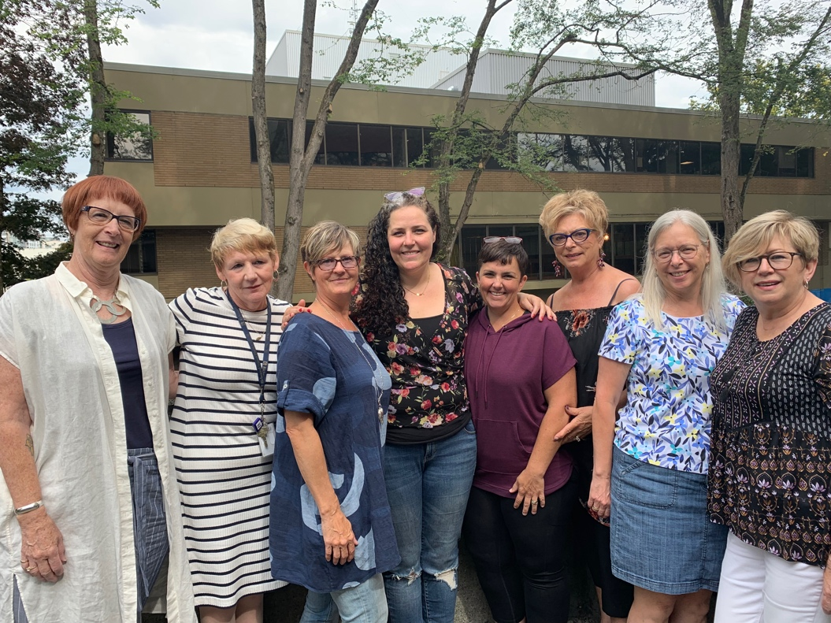
Meet the REAP Staff

Left to right: Leslie (instructor), Kathleen (REAP Administrator), Monika (instructor), Kate (instructor), Heather (instructor), Chris (instructor and supervisor), Deb (instructor and supervisor) and Darlene (supervisor). Missing: Maria (instructor and supervisor) & Marie (instructor)

