Foundations Language Arts

Foundations Language Arts (Levels 1 to 8) enable students to develop knowledge and skills in English Language Arts in order to be successful in courses required for graduation in the Adult Graduation Program. Students learn to develop their speaking, listening, fluency, conversation, comprehension and writing skills.
Day Classes:
Monday to Thursday,
9 a.m.-11:30 a.m. or 12 p.m.-2:30 p.m.
Evening Classes:
Tuesday & Thursday,
6:30 p.m.-9 p.m.
Format: Teacher-directed. In-person attendance required.

Adult Secondary Upgrading
Taking high school courses can help with various educational paths – working towards high school graduation, upgrading for work or for entrance into a post-secondary program.

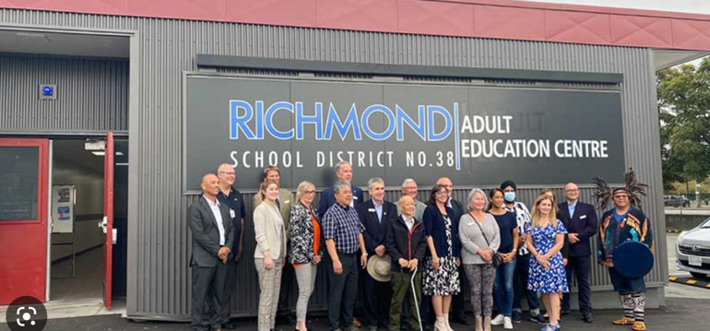

Day Classes:
English:
Monday to Thursday,
9 a.m.-11:30 a.m. or 12 p.m.-2:30 p.m.
Math & Sciences:
Monday to Thursday,
9 a.m.-11:30 a.m. or 12 p.m.-2:30 p.m.
Humanities/General Academics:
Monday & Wednesday,
9 a.m.-11:30 a.m.
Evening Classes:
Tuesday & Thursday,
6:30 p.m.-9 p.m.
Format: Teacher-directed or Blended learning (computer programs with teacher support). In-person attendance required.

Adult Secondary Upgrading

English Courses

Composition 10
Creative Writing 10
English Studies 12
English First Peoples 12
Literary Studies 11

Math & Science Courses

Math 9
Math 10 Foundations & Pre-Calculus
Math 10 Workplace
Math 11 Foundations
Math 11 Pre-Calculus
Math 11 Workplace
Math 12 Apprenticeship
Math 12 Calculus
Math 12 Foundations
Math 12 Pre-Calculus
Life Sciences (Biology) 11
Anatomy & Physiology (Biology) 12
Chemistry 11
Chemistry 12
Physics 11
Physics 12

Humanities/General Academic Courses

Social Studies 10
Explorations in Social Studies 11
Science for Citizens 11
20th Century World History 12
BC First Peoples 12
Career Life Education 12
Child Development and Caregiving 12
Comparative World Religions 12
Law Studies 12
Philosophy 12
Physical Geography 12
Social Justice 12

----------------------------------------------------------------
Need academic advice?
Contact Bob Mostat, our Academic Advisor at 604-668-7899 ext. 1 or e-mail at bmostat@sd38.bc.ca.
Be prepared to provide documents for review (see “Documents Required for Registration”.

----------------------------------------------------------------

Program Location
Richmond Adult Education Centre
12091 Cambie Road

Term Dates
Day Classes (English, Math & Science):
Term 3: January 31, 2023 - April 12, 2023
Term 4: April 19, 2023 - June 14, 2023

Day Classes (General Academics):
Semester 2: January 30, 2023 - June 12, 2023

Evening Classes:
Semester 2: January 26, 2023 - May 30, 2023

When to Register
Day Classes (English, Math & Science):
Term 3: starting January 12, 2023 (9 p.m.)
Term 4: starting March 30, 2023 (9 p.m.)

Day Classes (Humanities/General Academics):
Semester 2: starting January 12, 2023 (9 p.m.)

Evening Classes:
Semester 2: starting January 12, 2023 (9 p.m.)

How to Register
- Online: www.richmondce.ca
- By phone: 604-668-7899
ext. 1 – for Math, Science & General Academic courses
ext. 2 – for Foundation Language Arts/English courses
- In person at 12091 Cambie Road, Richmond

Documents Required for Registration
- Proof of Status in Canada (one of the following)
- Canadian Birth certificate
- Valid Canadian Passport
- Valid Permanent Resident or Citizenship Card
- Valid Study Permit

- Proof of Status in Canada (one of the following)
- Canadian Birth certificate
- Valid Canadian Passport
- Valid Permanent Resident or Citizenship Card
- Valid Study Permit

- Proof of Residency in B.C. with CURRENT address listed (any two of the following)
- BC Services Card
- BC Driver’s Licence
- BC ID card
- Rental Agreement
- Utility Bills
- Property Tax Assessment
- Bank/Mortgage Documents

- School Records
- BC Transcript of Grades
- Permanent Student Record or school report card

Course Prerequisites
Richmond Continuing Education has established minimum prerequisite marks and courses. Some students may be required to complete an English Assessment in order to be placed in courses within the Adult Secondary Graduation Program.

What is an English Assessment?
To be taken by students who wish to register for an English course with us and have not completed Grade 10 English in Canada, the English Assessment covers four parts: Grammar; Reading; Listening and Writing. It usually take about two hours to complete on a computer, at the Adult Education Centre.
Assessment results are valid for one year and are used for class placement purposes only.
Cost: $30, payable by credit card.
To Register: www.richmondce.ca

Course Fees

Type of Students | Permanent Residents, Canadian Citizens, Convention Refugees | International Students  with Valid Study Permit
High School Graduates | $0 (see tuition-free course list below)  $550 for courses not listed below | $1,500 per course
Non-High School Graduates | $0 | $1,500 per course

Tuition-Free Courses Available to Graduated Adults

Foundation Language Arts/ English | Math | Science
FLA Levels 1-8  Literary Studies 11, English Studies 12  English First Peoples 12 | Math 11  Math 12 | Chemistry 11 & 12  Life Sciences 11  Anatomy & Physiology 12  Physics 11 & 12

